Настройка SAMBA

Установка пакетов SAMBA
debian-practice:/home/user# apt-cache search samba | more
libsmbclient - shared library that allows applications to talk to SMB/CIFS servers
samba - a LanManager-like file and printer server for Unix
samba-common - Samba common files used by both the server and the client
samba-doc - Samba documentation
smbclient - a LanManager-like simple client for Unix
smbfs - mount and umount commands for the smbfs (for kernels >= than 2.2.x)
swat - Samba Web Administration Tool
kdenetwork-filesharing - network filesharing configuration module for KDE
libcrypt-smbhash-perl - generate LM/NT hash of a password for samba
smbldap-tools - Scripts to manage Unix and Samba accounts stored on LDAP
smb4k - A Samba (SMB) share advanced browser for KDE
snort-common - flexible Network Intrusion Detection System [common files]
libsmbclient-dev - libsmbclient static libraries and headers
cadaver - command-line WebDAV client
distcc - Simple distributed compiler client and server
samba-doc-pdf - Samba documentation (PDF format)
samba-tools - tools provided by the Samba suite
snort - flexible Network Intrusion Detection System
snort-common-libraries - flexible Network Intrusion Detection System ruleset
php-auth - PHP PEAR modules for creating an authentication system
smbc - samba-commander - curses based samba network browser
fusesmb - filesystem client based on the SMB file transfer protocol
xmms2-plugin-smb - XMMS2 - Samba transport
gsambad - GTK+ configuration tool for samba (transitional package)
gadmin-samba - GTK+ configuration tool for samba
xsmbrowser - X11 tool for navigating SMB Networks
komba2 - KDE Samba browser
nautilus-share - Nautilus extension to share folder using Samba
snort-doc - Documentation for the Snort IDS [documentation]
libpam-smbpass - pluggable authentication module for SMB/CIFS password database
tksmb - SMB (Samba and Windows) network browser
libpam-mount - PAM module that can mount volumes for a user session
ldapscripts - Add and remove user and groups (stored in a ldap directory)
ldap-account-manager - webfrontend for managing accounts in an LDAP directory
samba-dbg - Samba debugging symbols
dbench - The dbench (disk) and tbench (TCP) benchmarks
smb2www - SMB/CIFS network client with a web interface
egroupware-sambaadmin - web-based groupware suite - Samba administration application
distccmon-gnome - GTK+ monitor for distcc a distributed client and server
python-ldaptor - Pure-Python library for LDAP
snort-mysql - flexible Network Intrusion Detection System [MySQL]
linpopup - X Window System port of Winpopup, running over Samba
gosa - Web Based LDAP Administration Program
libfilesys-smbclient-perl - perl interface to access Samba filesystem
dpsyco-samba - Automate administration of access to samba
libnet-nbname-perl - NetBIOS Name Service Requests
python-smbpasswd - This module can generate both LANMAN and NT password hashes
snort-pgsql - flexible Network Intrusion Detection System [PostgreSQL]
gadmin-tools - GTK+ server administration tools
auth2db-filters - Auth2db defaults filters pack
ctdb - clustered database to store temporary data
libroxen-ntuserauth - WinNT/SMB user authentication module for the Roxen Challenger web server
debian-practice:/home/user# apt-get install samba samba-common samba-doc smbclient
Чтение списков пакетов... Готово
Построение дерева зависимостей
Чтение информации о состоянии... Готово
Будут установлены следующие дополнительные пакеты:
libcups2 libtalloc1 libwbclient0
Предлагаемые пакеты:
cups-common smbldap-tools ldb-tools samba-doc-pdf smbfs
НОВЫЕ пакеты, которые будут установлены:
libcups2 libtalloc1 libwbclient0 samba samba-common samba-doc smbclient
обновлено 0, установлено 7 новых пакетов, для удаления отмечено 0 пакетов, и 0 пакетов не обновлено.
Необходимо скачать 0B/22,2MB архивов.
После данной операции, объём занятого дискового пространства возрастёт на 55,9MB.
Хотите продолжить [Д/н]? y
Предварительная настройка пакетов ...
Выбор ранее не выбранного пакета libcups2.
(Чтение базы данных... на данный момент установлено 21956 файлов и каталогов.)
Распаковывается пакет libcups2 (из файла .../libcups2_1.3.8-1lenny4.1_i386.deb)...
Выбор ранее не выбранного пакета libtalloc1.
Распаковывается пакет libtalloc1 (из файла .../libtalloc1_1.2.0~git20080616-1_i386.deb)...
Выбор ранее не выбранного пакета libwbclient0.
Распаковывается пакет libwbclient0 (из файла .../libwbclient0_3.2.5-4_i386.deb)...
Выбор ранее не выбранного пакета samba-common.
Распаковывается пакет samba-common (из файла .../samba-common_3.2.5-4_i386.deb)...
Выбор ранее не выбранного пакета samba.
Распаковывается пакет samba (из файла .../s/samba/samba_3.2.5-4_i386.deb)...
Выбор ранее не выбранного пакета samba-doc.
Распаковывается пакет samba-doc (из файла .../samba-doc_3.2.5-4_all.deb)...
Выбор ранее не выбранного пакета smbclient.
Распаковывается пакет smbclient (из файла .../smbclient_3.2.5-4_i386.deb)...
Обрабатываются триггеры для man-db ...
Настраивается пакет libcups2 (1.3.8-1lenny4.1) ...
Настраивается пакет libtalloc1 (1.2.0~git20080616-1) ...
Настраивается пакет libwbclient0 (2:3.2.5-4) ...
Настраивается пакет samba-common (2:3.2.5-4) ...

Creating config file /etc/samba/smb.conf with new version
Настраивается пакет samba (2:3.2.5-4) ...
Generating /etc/default/samba...
tdbsam_open: Converting version 0 database to version 3.
account_policy_get: tdb_fetch_uint32 failed for field 1 (min password length), returning 0
account_policy_get: tdb_fetch_uint32 failed for field 2 (password history), returning 0
account_policy_get: tdb_fetch_uint32 failed for field 3 (user must logon to change password), returning 0
account_policy_get: tdb_fetch_uint32 failed for field 4 (maximum password age), returning 0
account_policy_get: tdb_fetch_uint32 failed for field 5 (minimum password age), returning 0
account_policy_get: tdb_fetch_uint32 failed for field 6 (lockout duration), returning 0
account_policy_get: tdb_fetch_uint32 failed for field 7 (reset count minutes), returning 0
account_policy_get: tdb_fetch_uint32 failed for field 8 (bad lockout attempt), returning 0
account_policy_get: tdb_fetch_uint32 failed for field 9 (disconnect time), returning 0
account_policy_get: tdb_fetch_uint32 failed for field 10 (refuse machine password change), returning 0
Importing account for root...ok
Importing account for daemon...ok
Importing account for bin...ok
Importing account for sys...ok
Importing account for sync...ok
Importing account for games...ok
Importing account for man...ok
Importing account for lp...ok
Importing account for mail...ok
Importing account for news...ok
Importing account for uucp...ok
Importing account for proxy...ok
Importing account for www-data...ok
Importing account for backup...ok
Importing account for list...ok
Importing account for irc...ok
Importing account for gnats...ok
Importing account for nobody...ok
Importing account for libuuid...ok
Importing account for Debian-exim...ok
Importing account for statd...ok
Importing account for user...ok
Importing account for sshd...ok
Importing account for ftp...ok
Добавляется группа `sambashare' (GID 106) ...
Готово.
Starting Samba daemons: nmbd smbd.
Настраивается пакет samba-doc (2:3.2.5-4) ...
Настраивается пакет smbclient (2:3.2.5-4) ...
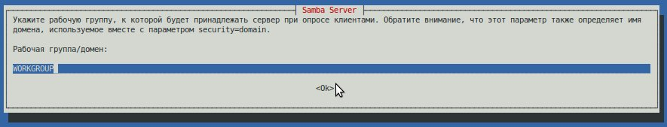
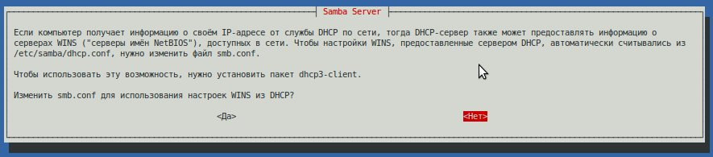

Настройка файлового доступа
Отредактировать файл /etc/samba/smb.conf
В разделе global добавить:
dos charset = 866
unix charset = utf-8
display charset = 1251
client code page = 1251

В разделе homes изменить
read only = no
create mask = 0775
directory mask = 0755

Перезапуск сервера
debian-practice:/etc/samba# /etc/init.d/samba restart
Stopping Samba daemons: nmbd smbd.
Starting Samba daemons: nmbd smbd.

Добавление пользователя
debian-practice:/etc/samba# smbpasswd -a user
New SMB password:
Retype new SMB password:
init_iconv: Conversion from UTF-16LE to 1251 not supported
init_iconv: Attempting to replace with conversion from UTF-16LE to ASCII
init_iconv: Conversion from utf-8 to 1251 not supported
init_iconv: Attempting to replace with conversion from ASCII to ASCII
init_iconv: Conversion from 1251 to UTF-16LE not supported
init_iconv: Attempting to replace with conversion from ASCII to UTF-16LE
init_iconv: Conversion from 1251 to utf-8 not supported
init_iconv: Attempting to replace with conversion from ASCII to ASCII
init_iconv: Conversion from 1251 to 866 not supported
init_iconv: Attempting to replace with conversion from ASCII to ASCII
init_iconv: Conversion from 1251 to UTF8 not supported
init_iconv: Attempting to replace with conversion from ASCII to ASCII
init_iconv: Conversion from 1251 to UTF-16BE not supported
init_iconv: Attempting to replace with conversion from ASCII to UTF-16BE
init_iconv: Conversion from 866 to 1251 not supported
init_iconv: Attempting to replace with conversion from ASCII to ASCII
init_iconv: Conversion from UTF8 to 1251 not supported
init_iconv: Attempting to replace with conversion from ASCII to ASCII
init_iconv: Conversion from UTF-16BE to 1251 not supported
init_iconv: Attempting to replace with conversion from UTF-16BE to ASCII

Проверка подключения
